KB
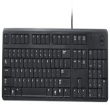 | Dell 104 Quiet Key | USB 2.0  104 Quiet Key  Spill-resistant keyboard  Adjustable tilt  USB connectivity | Rs. 499 | 25 | Rs. 374
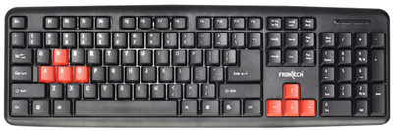 | FRONTECH JIL-1671 | PS/2  104 Keys  Waterproof  Multi-language  Fashion Streamline Design | Rs. 206 | 0 | Rs. 206
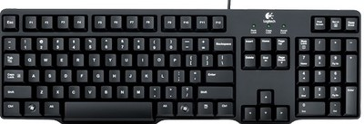 | Logitech K100 Classic | PS/2  100 Keys  Spill-resistant design  Full-size keyboard  8 additional hotkeys | Rs. 445 | 0 | Rs. 445
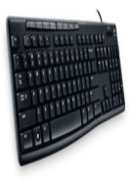 | Logitech K200 Media | USB 2.0  Instant access to applications  Comfortable  Thin profile  Durable keys | Rs. 999 | 30 | Rs. 699
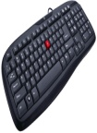 | iBall Winner | USB 2.0  103 Keys  Soft feel keys  Water resistant design  Sealed Membrane sheet | Rs. 700 | 32 | Rs. 475
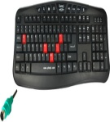 | Quantum QHM7880 | PS2  103 Keys  3 Pieces LED function  Water Spill Feature  Noiseless design | Rs. 599 | 16 | Rs. 499
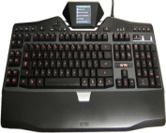 | Logitech G19 | - Two USB Ports  - Instant Media Access  LCD Game Pane  - Onboard Memory  12 programmable G-keys | Rs. 12990 | 18 | Rs. 10599
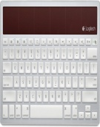 | Logitech K760 | Wireless  Powered by Any Light  Slim, Minimalist Design  Connection from up to 30 Feet  Mac OS X 10.5 and Above | Rs. 6599 | 18 | Rs. 5381
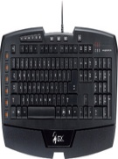 | Genius Imperator MMO/RTS | USB 2.0  1000 Hz Report Rate  1 ms Response Time  7 Media Keys  Palm Rest Option | Rs. 2995 | 18 | Rs. 2429
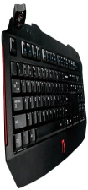 | Tt eSPORTS Challenger | USB 2.0  7 Multimedia Key  Macro Keys  Smart Cable Management  - Fan Device | Rs. 4200 | 8 | Rs. 3850
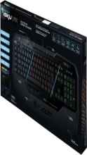 | Roccat ISKU FX | USB 2.0  - 5 Profile-status LEDs  1 ms Response Time  1000 Hz Polling Rate  - 2 m USB Cable | Rs. 7500 | 0 | Rs. 7500
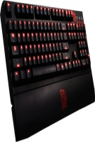 | Tt eSPORTS Meka G1 | - 7 Multimedia Keys  - Mechanical Keyboard  - 1000 Hz Polling Rate  - On-board Audio Jack  - USB Support | Rs. 11500 | 14 | Rs. 9800

